Trees, Stars, and Multiple Biological Sequence Alignment
Stephen F. Altschul and David J. Lipman
SIAM J. Appl. Math. Vol. 49, pp. 197-209, February 1989
Abstract
- Review of Carrillo and Lipman’s algorithm.
The central idea of Carrillo and Lipman’s algorithm is that the cost of the projection of an optimal multiple alignments onto two of its sequences must be at least as great as the distance between these sequences.

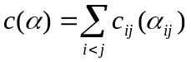
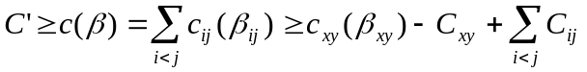
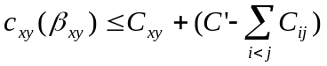
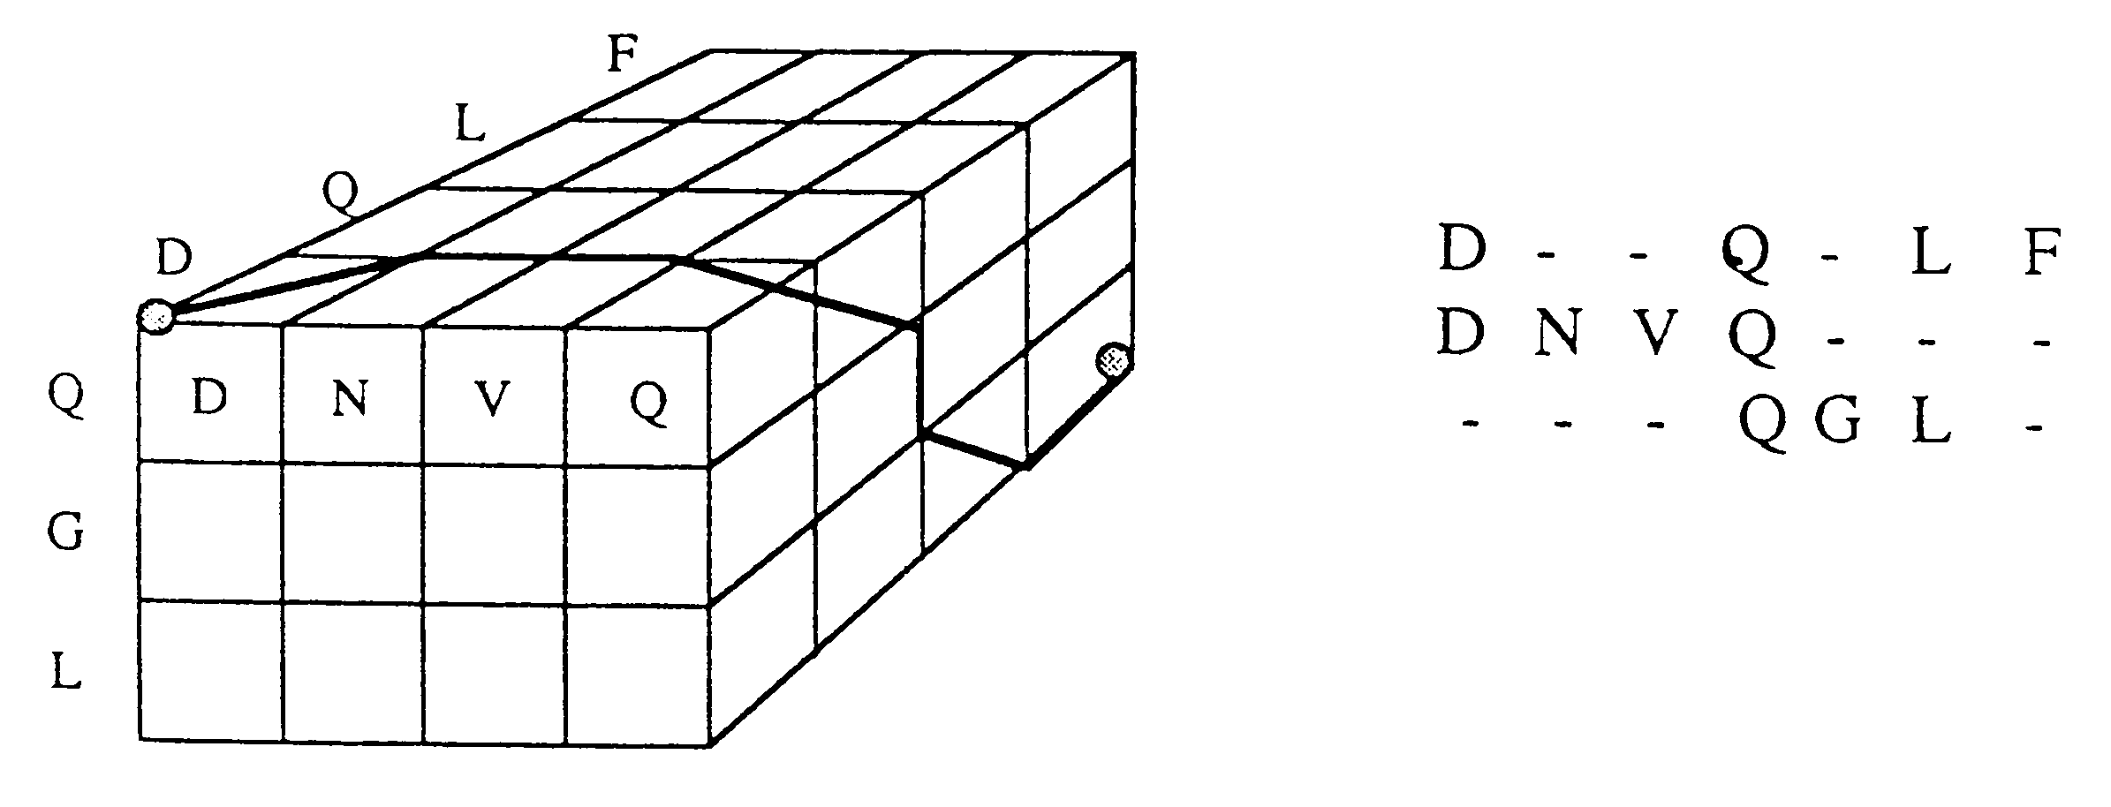
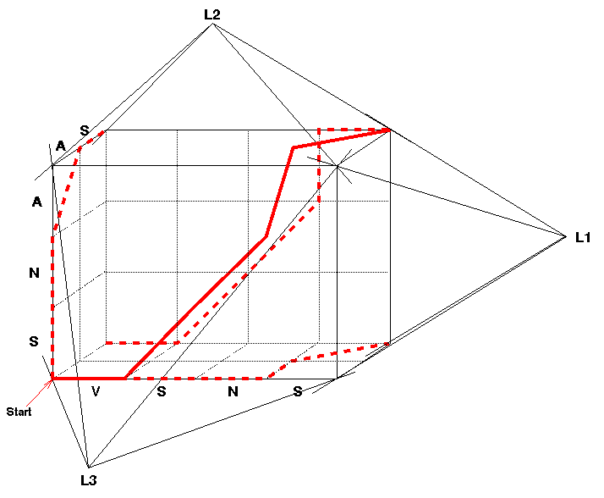
Carrillo and Lipman’s algorithm for finding optimal SP-alignments divides into three parts：
- finding the upper bound on the cost of each projection of an optimal alignment
- using these bounds to reduce the size of the dynamic programming lattice
- finding an optimal alignment within the reduced lattice
- Tree-alignments.

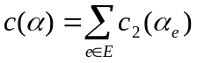
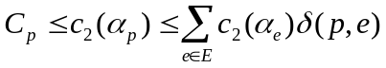
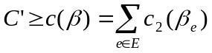

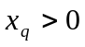
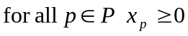
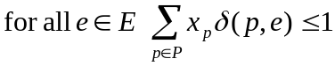

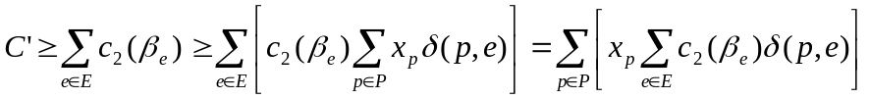
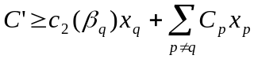
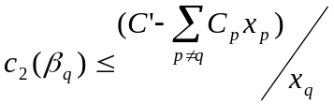

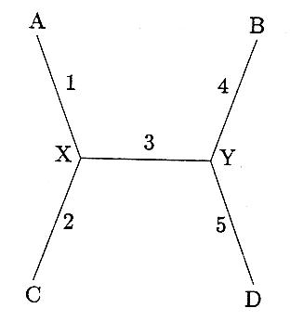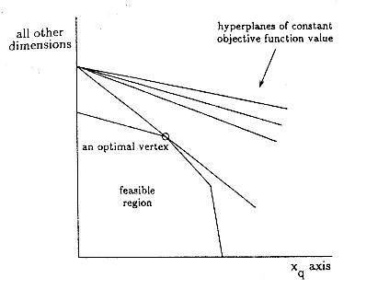

- Circular programming.
The problem is to choose 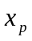 satisfying inequalities (10)-(12) that minimize 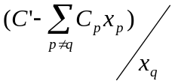

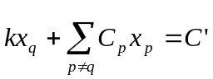
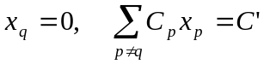
- Star-alignments.
Lemma 1. For a star-alignment, any vertex of the convex polyhedron defined by the equations (11) and (12) has all coordinates equal to zero, , or one.
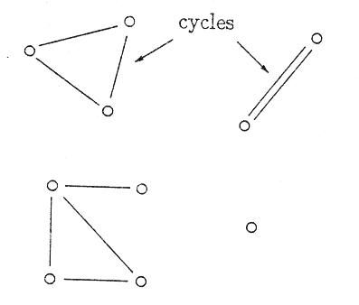

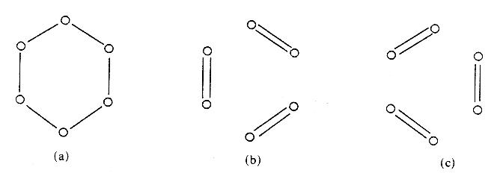

Theorem 1. In the feasible region corresponding to the inequalities (10) to (12) implied by a star, there always exists a vertex v minimizing (16) such that the following hold:
- The two nodes of G(v) corresponding to the sequences of pair q are adjacent.
- If the star has three edges, G(v) is either a cycle of size three, or a cycle of size two and an isolated node.
- If the star has more than three edges, G(v) consists of cycles of size odd or equal to two
Created by : Rei-Sing Cheng
Date : May 30, 2002

